

gREY tECH

Empowering Seniors



Warren Louresns: 9493224

Contents

Website goal 2

Mission statement 2

Short term goals 2

Long term goals 2

Intended Audience 2

Why people will visit the website 2

Scenarios and Personas 3

Bibliography 6

# Website goal

Grey Tech was founded June 7, 2020 with the aim of educating Seniors on how to operate modern technology. The website was created to fill a gap in society that saw seniors get left behind in a World that is being saturated by technology.

# Mission statement

* To empower seniors with the knowledge to understand and embrace technology.

## Short term goals

* Help show seniors that technology is a helpful tool to improve their lives rather than a barrier they cannot overcome.

## Long term goals

* Break the sigma that technology is only for the youth.
* In the next 20 years see all seniors embrace technology rather than resist it.

# Intended Audience

The intended audience for the site is seniors aged 65+ people that were born in an age before technology such as cell phones and computers were even a thought.

# Why people will visit the website

To educate seniors on the power and use of modern technology such as cell phones and computers. The website will also show them how modern technology can be beneficial to their own independence.

# Scenarios and Personas

Name: Mandy

Age: 66

Profession: Retired store clerk

Marriage status: Widowed

Vision: Poor

Language: Chines (Struggles to read English)

Health: healthy

1)

Scenario

Mandy is really close with her grand daughter which has reached the time in her life to leave her hometown and go study at a University located in the adjacent city.

Her granddaughter has gifted Mandy a new Laptop that has discord installed on it so that they can stay in touch daily.

“I have never owned or operated a laptop before. My late husband used to deal with such things. I am too old to start learning new things”

End goal

Operate the Laptop and the associated software with enough confidence and know how as to communicate with her all her distant family members.

Name: Glenn

Age: 71

Profession: Retired Builder

Marriage status: Single

Vision: good

Language: English

Health: healthy  
2)

Scenario

Glenn loves spending time with his family and normally would see them every weekend without fail. His grandchild loves spending the night where they stay up late having teddy wars and star gazing.

Since the rise of Covid19 Glenn has struggles being so isolated and not spending time with his loving family so he decided to invest in a tablet that he could use to video call his family. He has some experience with using tablets, but he has never used them outside of the work environment -invoicing clients and recording his work hours within a spreadsheet.

End goal

He would like to be competent in the use of popular social media software and websites such as facebook, discord and skype so that he can stay connected with his family

Name: Zack

Age: 68

Profession: Retired Banker

Marriage status: Married

Vision: poor

Language: English

Health: High blood pressure

3)

Scenario

Zack has high blood pressure and with his medical condition he has been forced to continue his doctor visits online due to Covid19 heightened restrictions. Zack has a laptop that he uses to send emails and watch religious videos on youtube. He knows his way around a computer and feels confident that with the right software he will have no issue with the online doctor visits.

End goal

Once Covid19 has gone in the history books and international travel has returned, Zack would like to have his blood pressure under control so that he and his wife Sophia can travel the United States of America in a minivan.

# Competitor analysis

## Competitor 1 ) SeniorNet

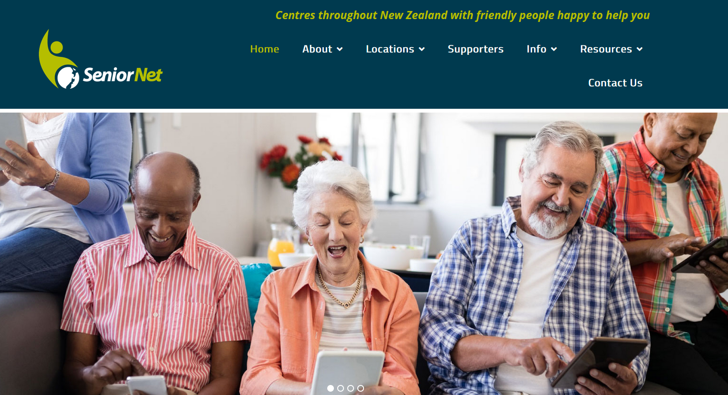

4) (SeniorNet, n.d.)

SeniorNet offers a similar service that our proposed website ‘Grey tech’ is offering as it claims to educate seniors in the use of modern technology.

## Colour pallet

 Prussian Blue

Blue colour represents wisdom, trust, depth and loyalty. It has some strong ties to the target demographic and is rather an appealing colour for both the footer and header of the website.

Buddha Gold

Buddha Gold is technically a gold colour but against the background it looks like slightly green. The colour gold represents wealth and prosperity, it also shares the traits of yellow which is warm and inviting.

Overall, not a bad colour choice for the logo.

White is used for the text that is found within the header navigation bar as well as the text in the footer. the decision to use white against the header/footer background colour Cello was a good choice as it stands out rather well and is easy to read. As for the body of the website the text colour switches to black while the background colour changes to white. Having the body background colour as white while the text is black is rather standard.

### Issues with the website

**Issue 1)** At first glance the website looks amazing with an image carousel displaying seniors enjoying technology, the landing page is clean and has a title clearly advertising the sites main focus “SeniorNet- Essential technology and Computer Skills for Seniors and Older Adults.”

However, there are some design and functional flaws that this site contains that are damaging their functionality. The first design flaw cannot be seen at first glance but when a user clicks on any of the navigation or logo held within the navigation.

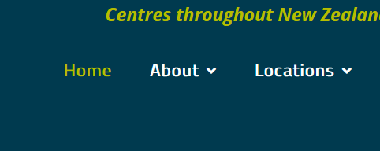

As you can see when the user clicks on a link there is a visible pink square that can be seen. I do not think that is was meant to be a design feature but rather a spacing aid when the developer was lining the navigation links.

**Issue 2)**

The header has a lot of wasted screen real estate and not sure why the contact us link is set on its new line. I think this is yet another developer oversight that was not picked up before launch.



**Issue 3)**

The website is reactive which is a good design but sadly when viewed on a phone the logo slightly overlaps the burger menu. Due to the demographic of the website’s target audience this could lead to user frustrations as users could inadvertently lick on the logo rather than clicking on the burger menu.

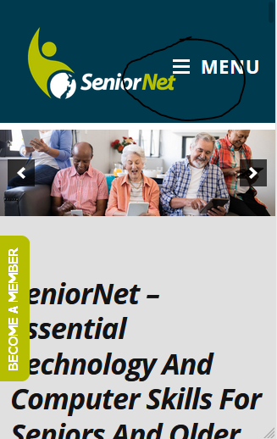

**Issue 4)**

The Content of the website is well laid out and presented in a manner fitting for the intended user. However, the landing page has articles about companies that support their cause rather than having content that clearly displays useful tutorials for the user of interested technology.

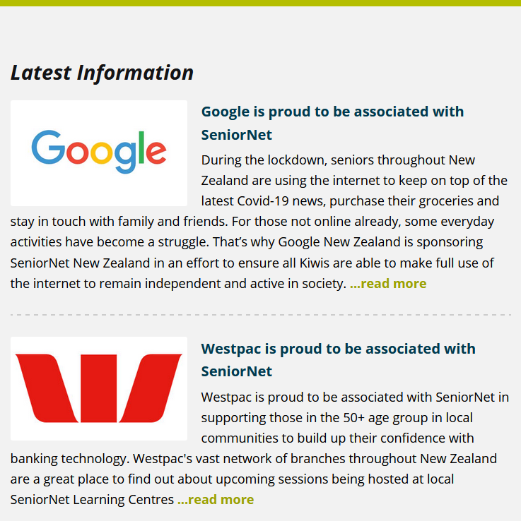

## Competitor 2) Grey Power

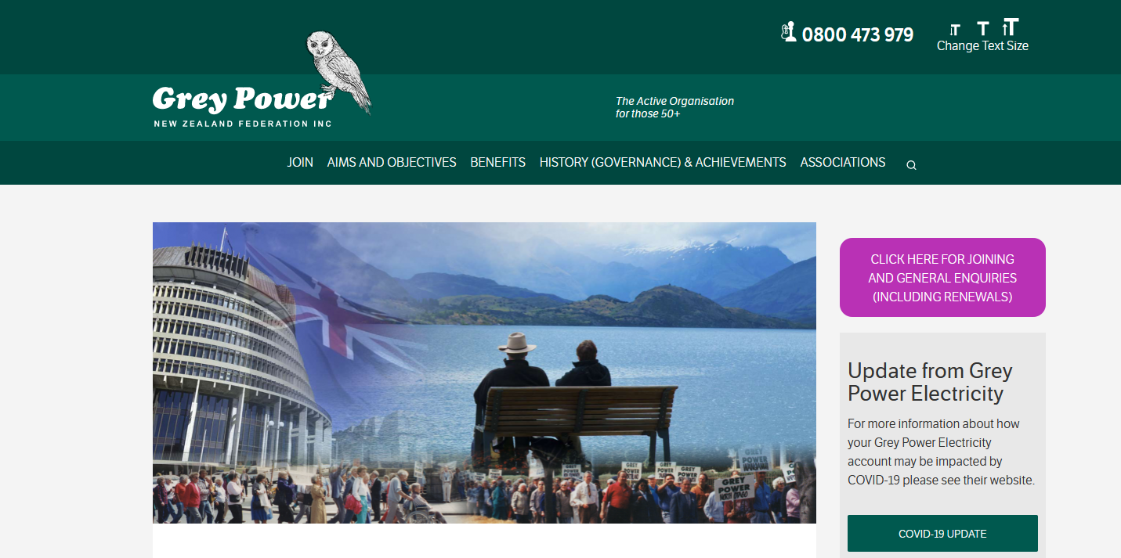

When you think of senior associations Grey Power is one that most, if not all will mention. So, it is no surprise to see that they have a website tailored to their target audience. Even though the website is not an educational platform in the way that “Grey Tech” will be preforming Grey Power does meet the needs of its target audience.

When members of the community become of age a lot do not understand what is available to them and this website meets those needs by informing concerned users of what is available to them in the way of benefits.

### Colour choice

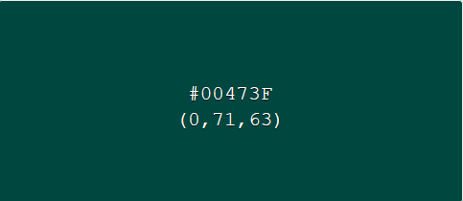 Aqua Deep

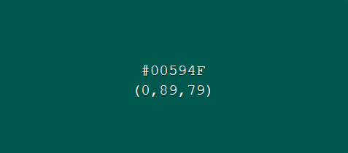Sherpa Blue

The colour pallet of the website is simple and clean, the two background colours are similar, but the two shades give the header good contrast. The white colour choice of the logo and header text is clearly visible against to two contrasting colours and gives the website a polished look.

### Design aspects Grey Power does well

**Landing page**

The landing page is clutter free and stays on point by only displaying a welcome message.

This design is fantastic as it does not distract the user with any unnecessary content.

All the information that the site provides is clearly marked in the navigation bar and strictly remains in the confines of the desired content.

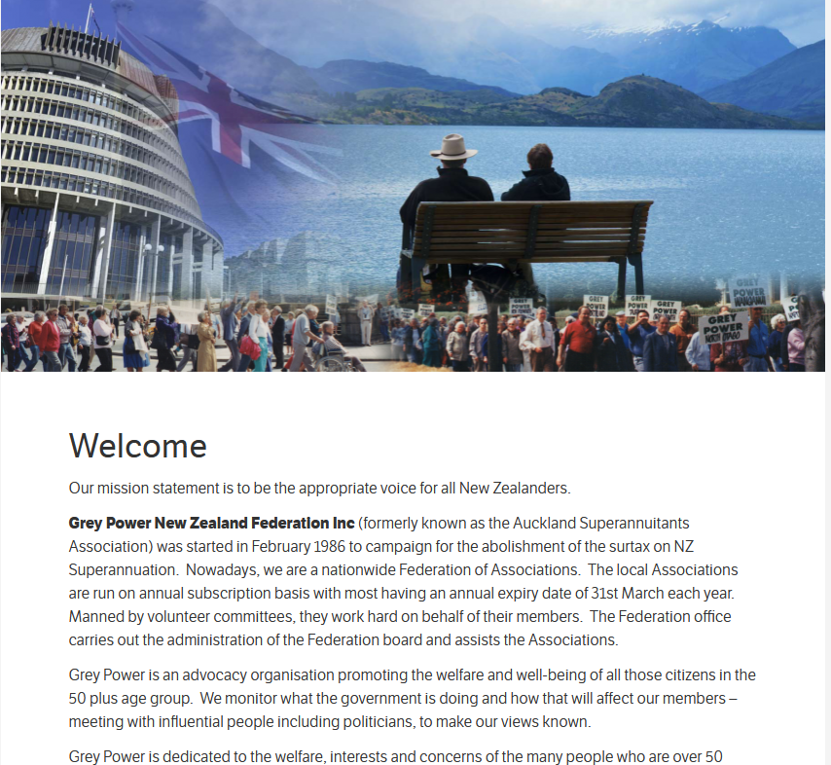

**Footer**

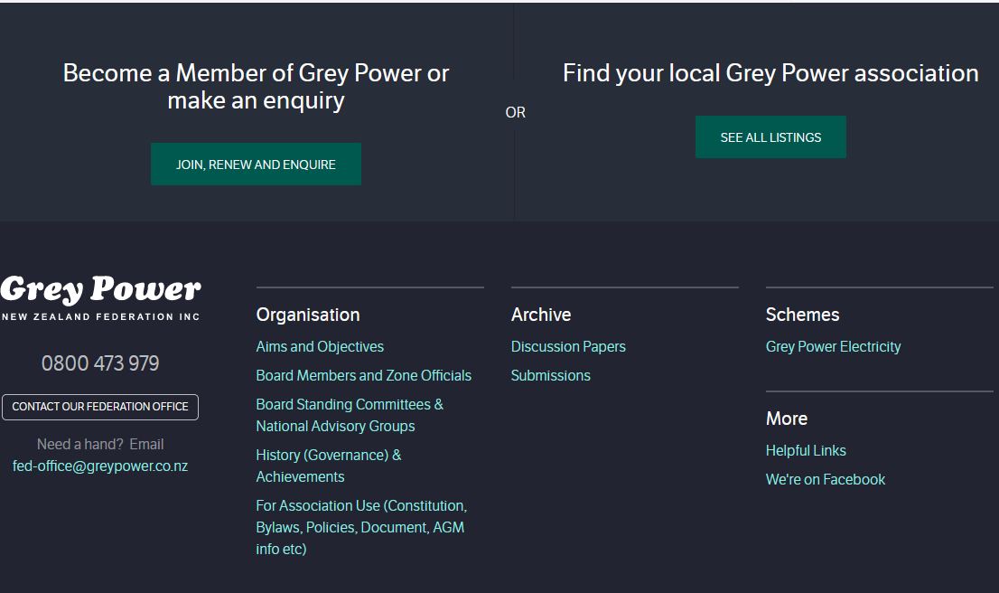

The footer contains all the additional information the user may want to access which leaves the website clutter free. the colour black with the text being white and green looks amazing and modern. I did notice that the footer does not contain any social media links such as facebook, twitter or Instagram as you would expect to see in most websites. By not having these social media links present shows that the designers had their audience in mind.

### Design aspects Grey Power fails to achieve

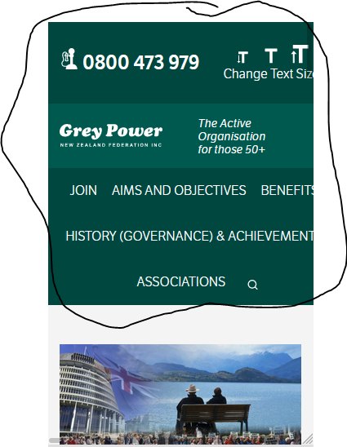

Grey Power is responsive, but it fails to deliver a polished header. The Header tried to adjust on scale but the designer should have just kept the logo, contact number and added a burger menu to clean up the header when viewed on cell phones.

### Final thoughts

The design and information Architecture is well thought out and executed with complete professional skill. The website does not stray from its information that it claims provide and offers the user a great source of information they may need to enjoy their later years of life.

As a developer I really like Grey Power’s website and will definitely be utilizing some of the aspects presented such as the clutter free landing page that sets the tone of the website, the l

## Competitor 3) Age Concern

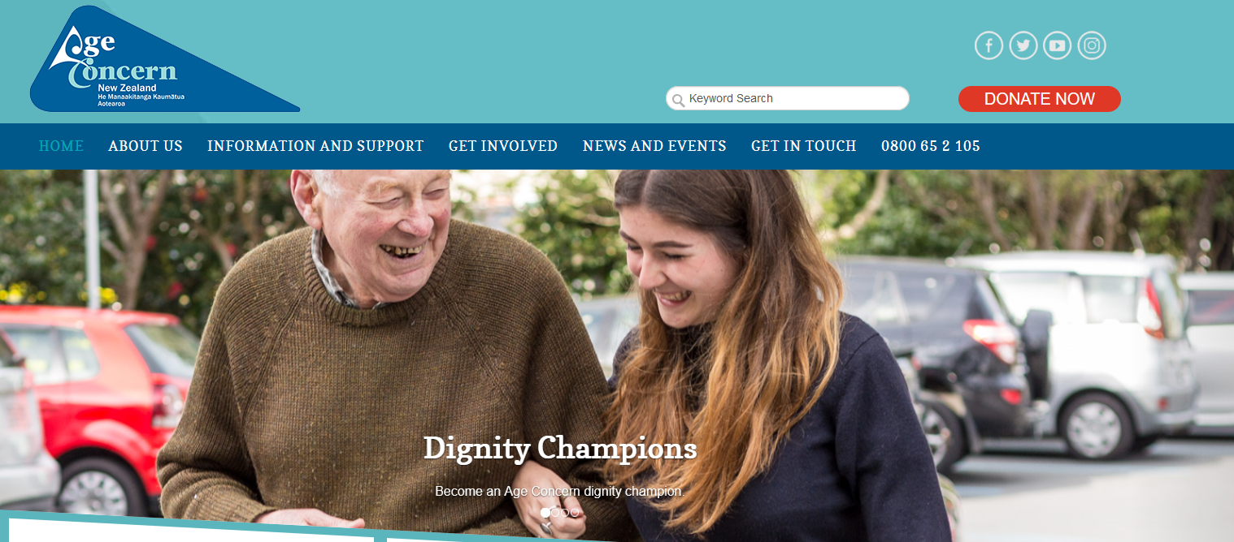

Age Concern is a website that has been created for the New Zealand aging population. As the name suggest the website focuses heavily on the welfare of the senior members of sociality by offering a range of information and Activities such as advice on online security, Nutrition, Exercise, Financial hardship as well as refresher courses on safe driving.

Age Concern has done an amazing job of providing not only important information to seniors but has also giving the local community the avenue to supply support in the way of fund raising or volunteer work.

This website would be the closest to what our “Grey Tech” would like to achieve, and I feel that they would work assisting each other in their goals and objectives.

### Design Aspects Age Concern does well

**Colour pallet**

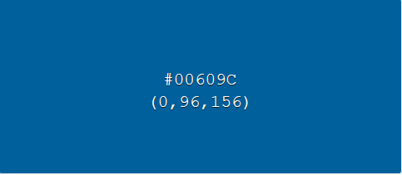



Blue different seems to be a favourite choice for such websites as they all possess the same colour pallet just varying in different shades.

Unlike the previously mentioned websites Age Concern decided to have their content body’s background to be a light blue colour instead of the conventional white choice. Even with so much colour on screen it does not distract the user from the content located in the body of the web page.

**Body**

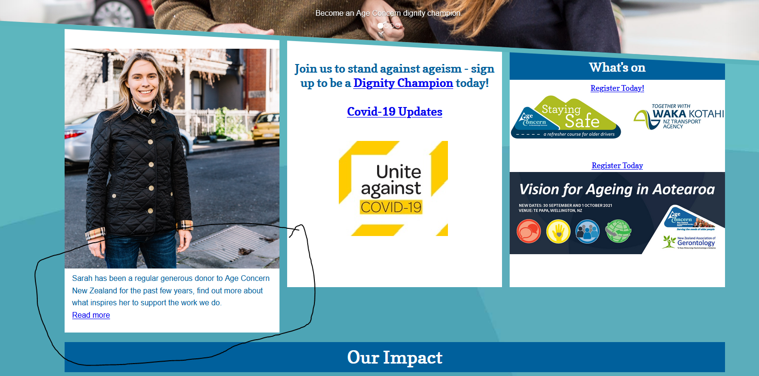

The information held within the body of the website seems to lack symmetry. As you can see in the image above the image on the left is larger in length than the other two. This imagery difference can be seen on several other pages.

I find these image consistencies to be distracting and make the content of the web page looked less organised and cluttered. This design oversight will not be taking place in “Grey Tech”

**Body continued**



What I really think Age Concern does really well is buy not only providing useful information to its users but also provides all the necessary links and contacts to empower the user to take action and achieve the goal of visiting the website in the first place.

This aspect that Age Concern does well strongly correlated with the goals of “Grey tech” and I hope to extend this feature with short online videos as well as contacts for more in-depth personalised lessons.

**Footer**

What I love about this footer is the design and minimalist approach. It was a cleaver method of having the company logo within the footer while keeping it clutter free.

This design choice is something that I really like and could see myself using in “Grey Tech’s” footer design.

I really love how the image of the elderly person is being active on a bike while walking his dog. This image draws your attention to the footer and the associated links that it contains. Overall a great design and extremely well executed.



# Site Content

As the primary aim of the website is to provide content for seniors to gain knowledge of the use of modern technology without judgment the content provided by the website will strictly adhere to its limitations.

The landing page will be clutter free with only an image carousel picturing a range of seniors enjoying technology showing them smile, laughing and being social not only with family but with friends as well.

There will be a button clearly located and marked as Login at the top right position of the screen. When the user clicks on the login button, they will be navigated to a login page. If the user has already registered, they can login using their credentials and have access to their personal information If not, the User can select another button labelled “Register” and Register themselves as a user.

At the top of the home screen there will be a logo, search bar and a navigation bar if a user clicks on a desired topic, they will be navigated to the appropriate page of the website where the use will get a brief overview as to what each lesson coverers. If a user wishes to attend a desired lesson, they will have the ability to enrol via a clearly marked button. Once the user clicks on the enrol button a popup will appear displaying a series of word phrases. These word phrases form a token. Once the desired lecturer is available for the lesson, they will issue a date and time. The user can then click on the lesson on the specified time, and they will need to provide their token. The system will check if both the tokens provided by the lecturer and student match. If so, then the student will gain access to the virtual classroom where the lesson can begin.

## Functional requirement

Login button

Registration button

Registration form

Search bar with associated button

Navigation bar

Token generation

Token distribution

Example of Grey Tech landing page

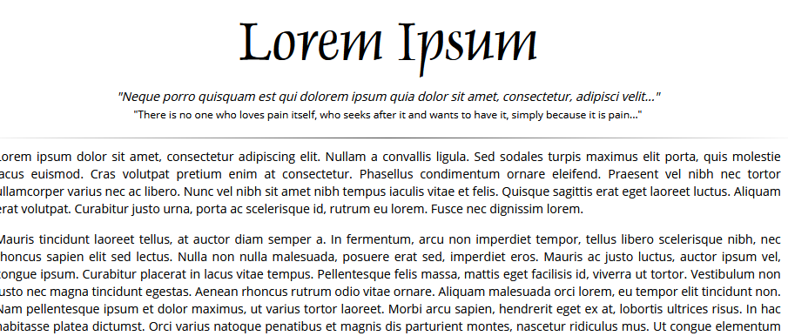

# Site Structure

**Organisational metaphor-** gives an overview as to how the business operates by explaining its methods of operation (Nordquist, 2019)

**Functional metaphor-** is when a website presents tasks in a way like that if you where to undertake the same tasks in person. For example, if a user wanted to get hold of a lecturer for help in the traditional method they would walk up to the lecturer and do so. On the website the student can still ask for help but through an online chat system (8.2. Metaphor Exploration, n.d.).

**Visual metaphor-** Is when you display something new in a similar manner that targeted users are familiar with. For example, by having the login button located in the top right of the screen with the same image that users expect to see a login button to look like (8.2. Metaphor Exploration, n.d.).

## A picture containing text Description automatically generatedGrouping and Label Content

# Define navigation

**Global navigation** – Are a set of links, buttons and search bars that will remain onscreen regardless of what page of the website you have accessed. Great example of global navigation is the header and footer of a website as they normally stay accessible regardless of where the user is located on the website (Implement Global Navigation to Improve Website Usability , n.d.).

**Local navigation-** is a series of links and buttons that make navigating on a given page more easily. This type of navigation will only be specific to the page the user on. For example, a link on a page will quickly take the user to the content displayed in the page’s subsection (Local navigation, n.d.).

# User Stories

1. As a teacher I want to be able to edit my products or services content directly from my personal account.
2. As a teacher I want to be able to issue tokens with one click of a button.
3. As an Administrator I want to have sole ability to remove or add products or services to the website.
4. As a member/user of the website I would like to be able to edit or remove my account information from the website.
5. As a user I want to be able to find what I want on the home page without the need to navigate to another screen.
6. As a user with poor vision, I do not want to read a lot.
7. As a user I want to use tokens with one click of a button on the desired product or service.

# Backlog/requirements

Register

Login

Edit personal accounts

Delete personal accounts

Members Register products or service

Members can issue tokens

Users Utilize token

Interface for members to accept a token

## Release backlog

Register new accounts

Login

Members can register products or services

Members can issue tokens

Members can receive tokens from users

# Crud matrix

|  |  |  |  |  |  |  |  |
| --- | --- | --- | --- | --- | --- | --- | --- |
| **User Action** | **Data type** | **tblCustomer** | **tblService** | **tbltoken** | **tblVolunteer** | **tblLesson** | **tblCity** |
| Register |  | Create |  |  |  |  | Create |
| Login |  | Read |  |  |  |  |  |
| Edit |  | Update |  |  |  |  | Read/update |
| Delete |  | Delete |  |  |  |  | Read/Delete |
| Register products or services |  |  | Create |  | update |  |  |
| View the lessons |  |  | Read | Read |  | Read |  |
| Token distribution |  |  |  | Read |  |  |  |
| Token Creation |  |  |  | Create |  |  |  |
| Enrol in lesson |  | update |  | Read |  |  |  |

# Assessment 2 Evaluate

## Describe the purpose of web framework

Before we get to have a look at different kinds of web frameworks, and what they are used for we must first get a better understand what a web framework is trying to achieve.

A web framework is a system of code libraries that offers a developer the opportunity to develop web applications with more ease. This is because the code libraries that comes with each framework offer prebuilt templates to start off the application. This creates not only a standard for developers but speeds up the creation of the application due to prebuild code that can be imported into the application so that the developers do not need to create the same component each time.

These code segments come in the form of components that can be retrieved from the appropriate frameworks’ website and can be used in several different parts of the application. So, if a web framework contains all the components needed to create a functional website, then why need a developer? and not just create a web application on your own? The answer is that even though frameworks are designed to speed up the development by providing ready build components it still requires a good foundation of HTML and CSS to get the best out of each framework.

Each web application consists of both a client side(frontend) and a server side (backend) component that work together to create a functional website. A frontend developer will create the needed elements that the user will interact with such as the buttons, forms, and everything the user will see on the screen.

A backend developer will code all the functionality that deals with passing the data from the forms displayed on the frontend and sends that data to the databases located in the backend.

Frontend developers create all the visuals that the client will see and interact with for examples the login forms.

## Deeper look at what frameworks consist of

For the purpose of the proposed website, we have decided to look at two popular web frameworks Angular and Vue.js

One of the more noticeable differences between Angular and Vue.js is their file structure when you create a component. In fig1 you can see the 4 files that are used for each component. Let us have a closer look as to what each file is used for and how it all works together. First, we have the css file that Is used to store all the style for our component such as font family and colours. The 2nd file is the html file that holds all the html so that the component can be seen on the screen through the browser. The 3rd file is the spec.ts file. In this file you will find all the deep logic that the component will be handling such as wait times and methods for detecting and changes that may have occurred that need to be updated. Finally in the 4th file you will find the ts file which is a typescript file that will house all the methods that the component will be using to undertake its task, such as onclick methods for the buttons.

**Fig1)**

As for Vue.js all it needs is 1 file that holds all the needed information and logic for the component. Such as the html, css and the methods. One reason why I like this file structure is because of the reduced amount of coupling a developer will need to make in order to render the component through the browser.

Take note as to the file extension of each component file in fig2. This specifies that the file is a Vue.js file.

**Fig2)**

# Routing

**Angular routing**

Another clear difference between the two frameworks is how they handle routing to render each component through the browser in order to display a functioning website.

Angular has a typescript file normally named app-routing-module.ts(fig1) which is used to import all the created components and then route all their paths so that the system knows where to find each component when it needs to execute it.

When it comes to calling each component in the master app.component..html file as seen in fig2) all it needs to do is reference the correct path to the component in order to use it.

**Fig2)**

**Vue.js routing**

This routing can be found in the router.ts file(fig1). As you can see the way Vue.js routes the components is different from that of Angular router calls. Within the router.ts file each component call has been broken down into 3 lines of code. The path, name and finally the component name

**Fig1)**

Finally, the way in which vue components are called within the App.vue file can be seen in fig2). As you can see the way in which both Angular and Vue.js call their respected components are similar to each other with some slight variance.

The variance I am referring to is the if statements that are present in both Angular and Vue.js. in Vue the if statement syntax is v-if while Angular’s if statement with the syntax of ngif.

Failing the noted differences, the functionality is executed the same.

**Fig2)**

**Login functionality**

**Angular**

In Angular the user input has been set to required. So if the field is left blank when the login button has been clicked and error message will be displayed informing the user that the field needs an input. NgModel is Angular’s means of binding data that the user inserts.

**Vue.js login**

In Login.vue the logic is almost the same but instead of using ngModel to handle user input Vue.js uses their own version which is v-model. The field is still set to required, but it uses the v-validate. You can see that if the user leaves the input field blank the same error message will be displayed.

**Backend**

As both Angular and Vue.js are frontend frameworks they both can use the express framework as the backend with attached mongodb as the specified database.

In order to store information within a mongodb document we need to specify which table we will be using and so we specify that we require(“mongoose”).

Mongoose is a gui that allows the user to see the tables and fields in a more user-friendly manner.

Following that, we make a new instance of the mongoose schema with the desired fields that the “User” table will hold. If the information inputted by the user has passed all the validation to see if it is new or existing data then the information will be stored within the table for later use. Both Angular and Vue.js frameworks.

**(fig1)**

This will work the same for the “Roles” table that will store the needed information to see which role the user will be linked to. This will give each user restrictions on the website based on their designated roll. This Will ensure that users that hold admin role will be able to add or remove items or services from the website

**Mongo**

Regardless of the framework used Express can send the data the user has entered to the Mongodb database. As seen in fig2 the tables can be seen in the Mongodb

**Fig2)**

When a user has successfully logged in the navigation bar will get additional tables based on the user’s role. In fig3) you can see that the user has the admin role which gives them access to the admin tab on top of the defaulted User tab which hold houses the non-sensitive information. From within the admin page the user will be able to add, update and delete items or services via a form on the webpage.

By having this role system in place, it will ensure that no user regardless of the web framework used will be able to access tabs that they are not authorized to do so.

As you can see the role functionality works the same regardless on which framework is currently in use and can visually look the same.

**Fig3)**

**Add/delete products in Angular**

for the Angular component that deals with adding or removing items we create a method for both pushing data or removing data with the use of splice. for adding items to list we push the data and then reset the textbox to clear once it has saved the data.

In the delete function we take the selected index as a parameter and pass a parameter into the splice function. This will subsequently remove the selected item from the list of products.

**Add/delete products in Vue.js**

As you can see in fig1) which can be found in product.vue there are all the methods for storing, editing, update a delete product they all work similar to each other but with slight differences. In the store function we have the same push function that the Angular store method uses, and it also sets the products textbox to clear so that the user can input more data.

In the editing method, the index and the product are used as parameters. We can also see that there is a Boolean “isEditing” which is set to true. The reason behind the Boolean is to alter the submit button to an update button.

The delete method will use the splice call with index as the parameter so that it can delete the selected item.

**Fig1)**

In the HTML file this is how we will call the methods discussed in the above paragraph. Now this method call will be the same for both frameworks and all we need to do is specify which method we wish to call alongside the click function which is part of the frameworks built in libraries.

This will be the display that they should see once they have clicked on the edit button. As you can see the ADD button has been replaced with an update button. The field wanting to be edited will be displayed in the textbox so that the value can change. After the update button has been pressed then the textbox will be set back to empty and the ADD button will return.

This will visually be the same for both frameworks.

**Register**

Regardless of the framework the display and functionality will work the same. When a user click on the Register tab they will be navigated to the register page. From here they will be able to register themselves as a user of the User of the website. If their credentials are not yet in the system and all the requirements are met such as password complexity, then they will see a message appear informing them of the successful registration.

# Pros and Cons

For this paper we had a small look at two popular web frameworks that can be used for the frontend portion of a web application. Now we will look at the pros and cons for both and finally give our recommendations for the web framework that would best suit the web application for the Grey Tech company.

**Angular**

The first framework we will be looking at is the Angular which uses Typescript

Some notable benefits (Angular, n.d.):

Cross-platform- In the World that is saturated with a wide range of devices it is important to have a framework that is adaptable. Angular supports web apps, native for mobile development and Desktop, which is support by Mac, Windows and Linux.

Speed and performance- Angular supports templates that speeds up the coding as it generates a good base to start coding. Code splitting is used with the router components which means that the page will only load the components it needs to display the request

Full development- Angular offers testing with the use of Karma that can help the developer test their changes on the fly. This will reduce potential errors on release.

Some Cons:

One of the cons for Angular is that although it has a ton of prebuilt components and a wealth of good documentation. Due to the way the routing works Angular has a slight learning curve.

**Vue.js**

Simplicity- Vue.js has a wide range of prebuilt components that can be used to speed up the coding and set the developer well on their way.

Integration- Vue.js can be integrated into other frontend frameworks such as React. Having this option of integration helps with customizing the application, as well as future proofing the application.

User-friendly- even through vue.js offers components and templates the same as Angular it is notably easier to pick up thanks to its strong community, and well-designed documentation.

Cons:

Being open source raises some concerns as the framework is driven by the wider community. When it comes to open-source projects security is always a major issue that needs to be considered as you do not know who had access to the core code of the components.

**Recommendation**

For the proposed Grey-Tech project I recommend using Vue.js as the framework of choice. The reason why I have chosen Vue.js over Angular is its easier learning curve and its wealth of documentation and tutorials available thanks to the open-source community.

As technology is continuously developing at an alarming rate you want to use a framework that is future proofed and has the ability to integrate with other frameworks with little effort.

Even though Angular is a good framework I feel that open-source software is the way of the future as this will ensure that the framework will be continuously getting developed regardless of the developer’s presence.

# Bibliography

1. mmLearn.org. (2020, September 14). *Caregiver training Blog*. Retrieved from mmLearn.org: <https://training.mmlearn.org/blog/is-grandma-always-cold-why-seniors-feel-cold-and-how-you-can-help>

*2) Elderly Parents Fed Up with COVID-19 Social Isolation?* (2020, June 22). Retrieved from Easy Living: https://easylivingfl.com/elderly-parents-covid-19-social-isolation/

3) *8.2. Metaphor Exploration*. (n.d.). Retrieved from docstore.mik.ua: https://docstore.mik.ua/orelly/web2/infoarch/ch08_02.htm

Angular. (n.d.). *FEATURES & BENEFITS*. Retrieved from angular.io: https://angular.io/features

Bondell, S. (2020, August 03). *Managing Elderly Cancer Patients During COVID-19* . Retrieved from Moffitt: https://moffitt.org/endeavor/archive/managing-elderly-cancer-patients-during-covid19/

*Elderly Parents Fed Up with COVID-19 Social Isolation?* (2020, June 22). Retrieved from Easy Living: https://easylivingfl.com/elderly-parents-covid-19-social-isolation/

*Implement Global Navigation to Improve Website Usability* . (n.d.). Retrieved from interaction-design.org: https://www.interaction-design.org/literature/article/implement-global-navigation-to-improve-website-usability

*Local navigation*. (n.d.). Retrieved from gustavus.edu: https://gustavus.edu/gts/Local_navigation

mmLearn.org. (2020, September 14). *Caregiver training Blog*. Retrieved from mmLearn.org: https://training.mmlearn.org/blog/is-grandma-always-cold-why-seniors-feel-cold-and-how-you-can-help

Nordquist, R. (2019, Novemeber 13). *Organizational Metaphor*. Retrieved from ThoughtCo: https://www.thoughtco.com/what-is-an-organizational-metaphor-1691361

Power, G. (n.d.). *Welcome*. Retrieved from Grey Power: https://greypower.co.nz/

SeniorNet. (n.d.). *SeniorNet- Essential Technology and Computer Skills for Seniors and Older Adults* . Retrieved from SeniorNet: https://seniornet.nz/